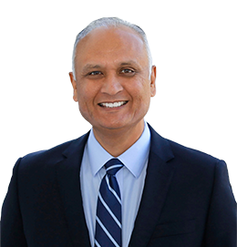

Senator Ed Hernandez (SD22) WHEN: May 4, 2018 from 1:00 pm – 2:30 pm
LOCATION: TBA
SPONSORS: Sponsorship Opportunities Available!

Senator Hernandez proudly represents the 22nd Senate District, which encompasses the cities and communities of the San Gabriel Valley, which include: Alhambra, Monterey Park, San Gabriel, South San Gabriel, Rosemead, El Monte, South El Monte, Baldwin Park, Irwindale, Industry, Avocado Heights, La Puente, Valinda, West Covina, Vincent, Azusa, Citrus, Covina, Temple City, Arcadia and surrounding neighborhoods.

Senator Hernandez serves as Chair for the Senate Committee on Health and also Chair for the Senate Committee on Legislative Ethics. He is also a member of the Business, Professions, and Economic Development Committee and the Senate Insurance Committee. Senator Hernandez is the Vice Chair of the San Gabriel Valley Legislative Caucus, made up of 12 Senators and Assemblymembers representing the greater San Gabriel Valley. This position has allowed him to work in cooperation with fellow legislators on issues critical to the San Gabriel Valley, including water and transportation.

